How to create a Panopto Video for assessment

Contents
What kind of video assessment? 1
Recording a presentation 1
Using Chromebook 1
Recording on a phone or tablet 1
Recording a presentation 2
Installing Panopto software 2
Recording with a Windows PC or Laptop 3
Recording with a Mac 6
Creating a recording using the browser (Necessary for Chromebook) 8
Recording a video on a phone or tablet and uploading 13
Submitting your assignment 15
Finding your submission point and submitting 15

What kind of video assessment?
There are several ways you can create a video for assessment so please read carefully and choose the option best suited for your content and the assignment. Check with your tutor about what you need to submit if you are unsure.

Recording a presentation
You may be asked to record while talking over a PowerPoint (similar to a lecture or presentation) in which case you will need a laptop, desktop computer (Mac or PC) and the Panopto software installed.

Using Chromebook
If you have a Chromebook then you cannot install the Panopto software but must use Chrome browser and record via a web browser. This option has less functionality than the software.

Recording on a phone or tablet
You may also record a video on your phone or tablet, but you cannot capture PowerPoint with this. You can only capture a video with the camera and upload it for submission, or use an existing video and upload it.

Recording a presentation
You’ll need a webcam, mic, laptop, or desktop PC or Mac, internet connection, and install the Panopto software. Most laptops have a camera and mic built in. You may need to buy a webcam for your desktop PC or Mac.

Installing Panopto software
1 Navigate to http://revision.derby.ac.uk/
2 Choose Course Resources (default) and click Sign in | 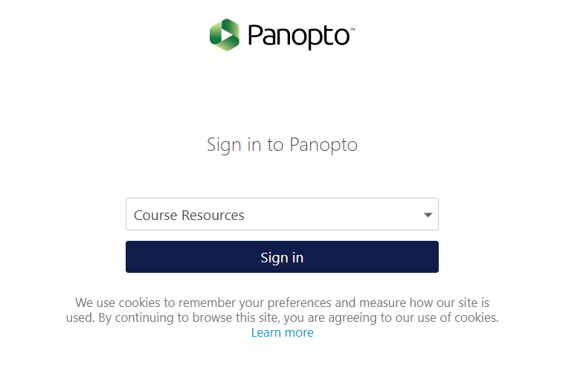
3 Enter you university username and password | 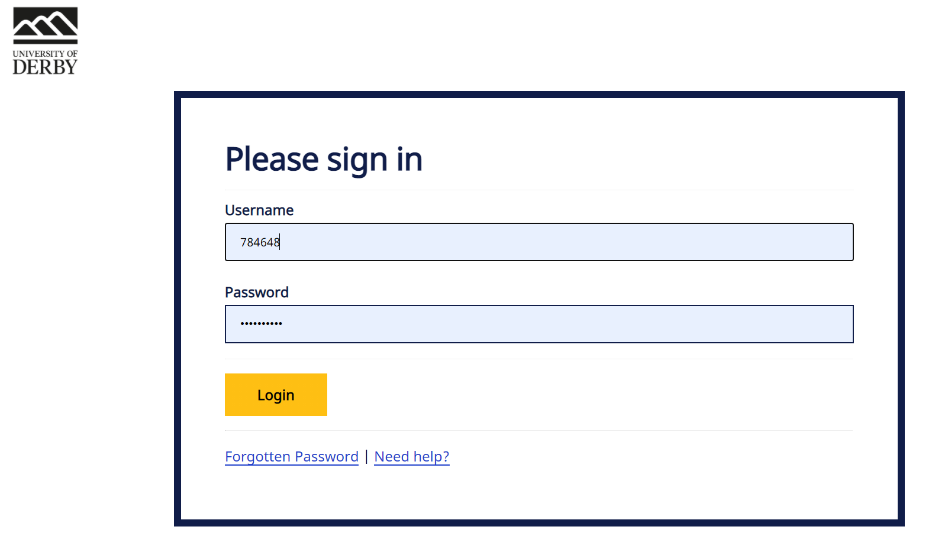
4 Click Download Panopto on the top right area of the screen. | 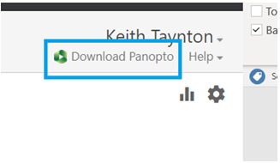
5 Choose the operating system (Windows or Mac). Click on the button to download the software.
6 Install the software on your machine by running the installer package.
7 Open the software. Mac and PC have different screens so please check the correct guidance below.

Recording with a Windows PC or Laptop

1 Choose the recording folder.  This must be set to My Folder.  Click the folder box and choose My Folder from the list. | 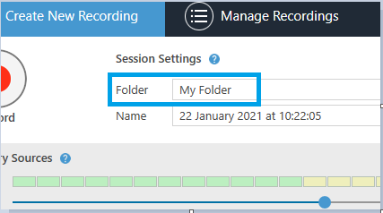
2 Change the name.  Click into the Name box and enter the title of the assignment. | 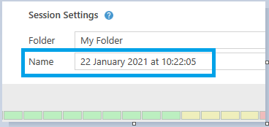
3 Check video.  If you want to record using your camera, click the Video box and choose the camera.  If you don’t want the camera, choose none. | 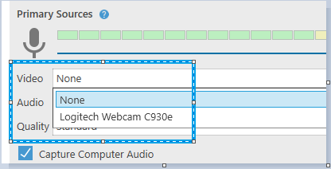
4 With camera enabled a preview of the camera will appear.  Check your hair and lighting. Make sure that your face is well lit. You should not have a light source like a window or lamp behind you. | 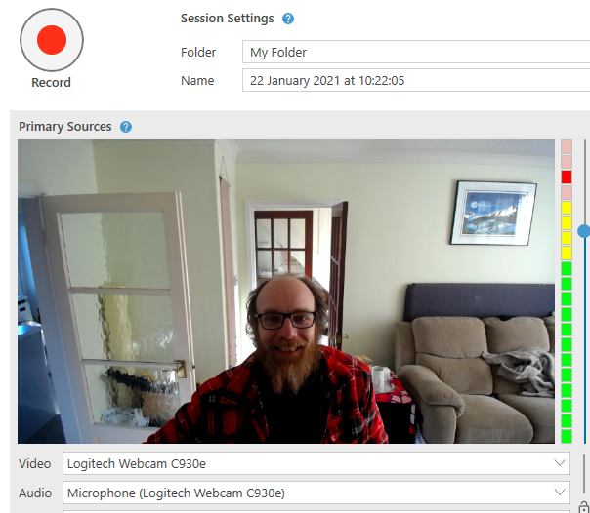
5 Check your audio.  Make sure your mic is working correctly. If you have multiple mics then you can choose them from the Audio dropdown. | 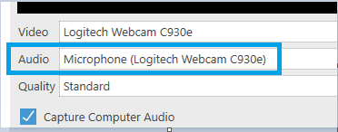
6 If your mic is working, when you speak the audio volume indicator will go up and down with green, yellow and red lights.  If the indicator is always hitting red then you should slide the blue circle down. This reduces the mic volume. Slide it down until the indicator only shows yellow or green.  If you only see a few green lights, slide the blue circle up to the top. This increases the mic volume. | 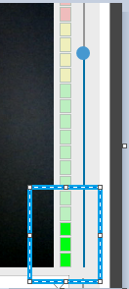
7 To record a powerpoint, tick the Capture Powerpoint box. You must have Powerpoint installed for this to work. | 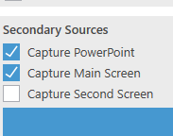
8 If you want to capture your desktop screen as well, for example if you want to show a website or word document, tick the Capture Main Screen.  Otherwise, leave Main Screen unticked. | 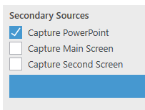
9 In the main area, click Open a Presentation | 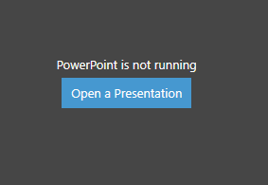
10 Choose your Powerpoint and click Open | 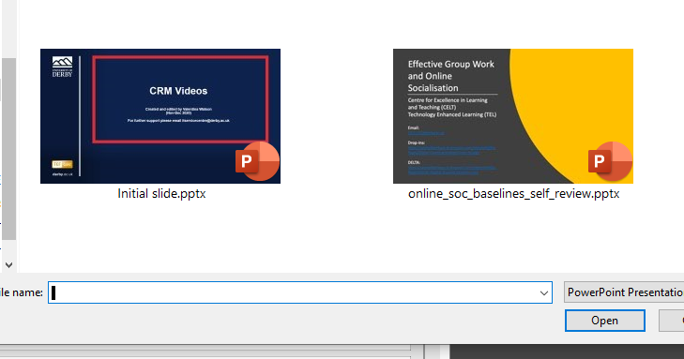
11 When you are ready to start, click Yes. This will open Powerpoint in presenter mode, and start the Panopto recording. | 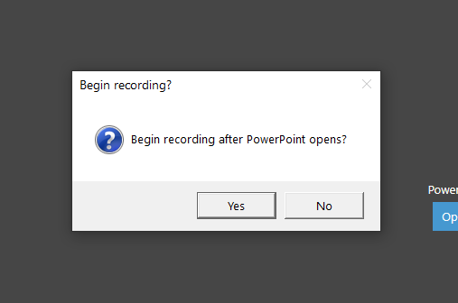
12 Do your presentation. When complete, come out of Powerpoint and open up the Panopto Recorder software by clicking the icon in the taskbar.
13 In the Panopto software, click the red Stop button | 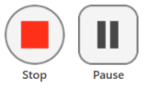
14 On the check screen, you can change the name of the recording and see the location of it. You should record into My Folder.  If you want to delete the recording click Delete and record again.  To keep the recording, click Done.  The recording will then upload onto the Panopto servers ready for you to submit.  Now see the next section on Submitting your assignment. | 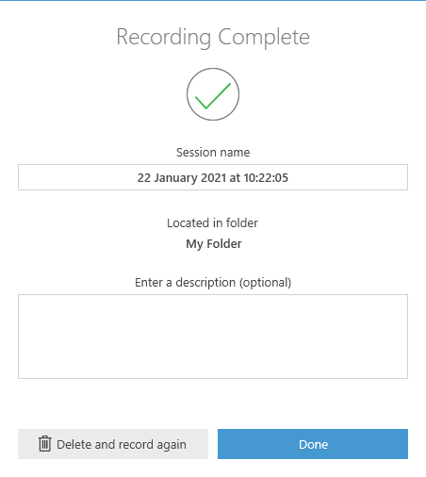

Recording with a Mac

1 Choose the recording folder.  This must be set to My Folder.  Click the folder box and choose My Folder from the list. | 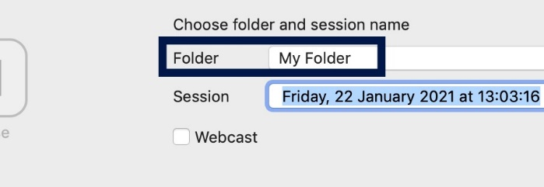
2 Change the name.  Click into the Name box and enter the title of the assignment. | 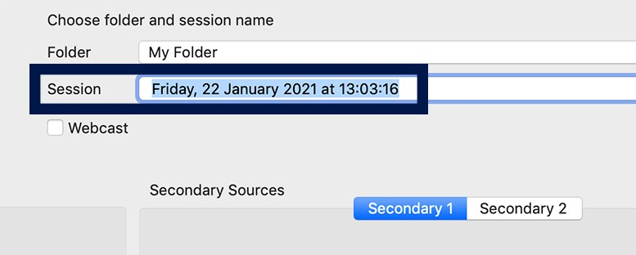
3 Check video.  If you want to record using your camera, click the Video box and choose the camera.  If you don’t want the camera, choose none.  When the camera is enabled a preview of the camera will appear.  Check you hair and the lighting. Make sure that your face is well lit. You should not have a light source like a window or lamp behind you. | 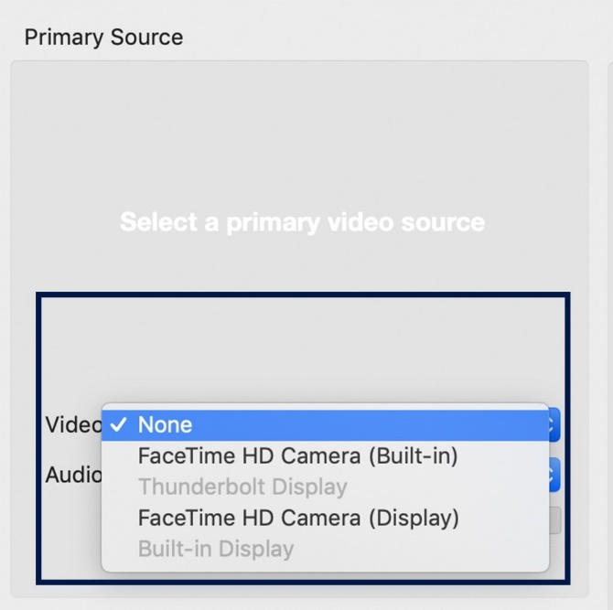
4 Check your audio.  Make sure your mic is working correctly. If you have multiple mics then you can choose them from the Audio dropdown.  If your mic is working, when you speak the audio volume indicator will go up and down with green, yellow and red lights.  You want your audio in the green area when you are talking. | 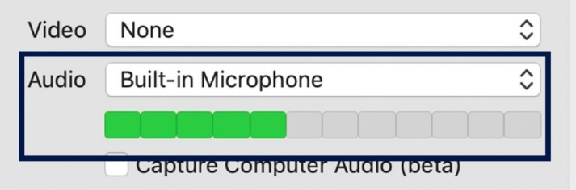
5 To record a PowerPoint (or Keynote) tick the Record PowerPoint (or Keynote) box.  You must have PowerPoint installed or Keynote for this to work. | 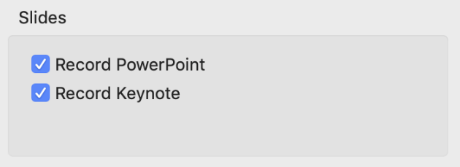
6 If you want to capture your desktop screen as well, for example if you want to show a website or word document choose the Source dropdown on the main screen area (Secondary source) and select the Built-in display. | 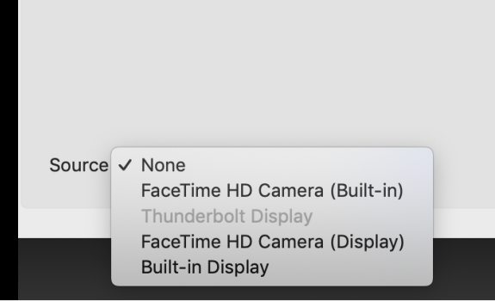
7 When you are ready to start, click Record. This will start the Panopto recording, and you can open PowerPoint and begin your presentation. | 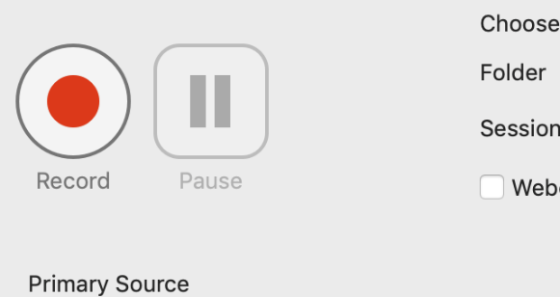
8 When complete, come out of PowerPoint and open the Panopto Recorder software by clicking the icon.
9 In the Panopto software, click the red Stop button. | 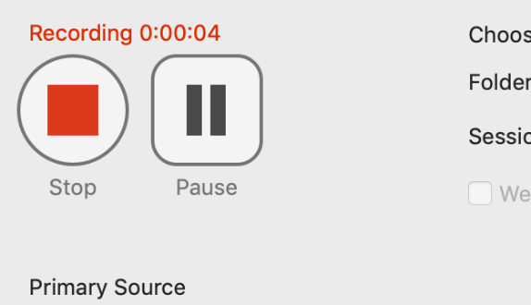
10 On the check screen, you can change the name of the recording.  If you want to delete the recording, click Delete and record again. (You cannot get the recording back)  To keep the recording, click Upload.  The recording will then upload onto the Panopto servers ready for you to submit.  Now see the next section on Submitting your assignment. | 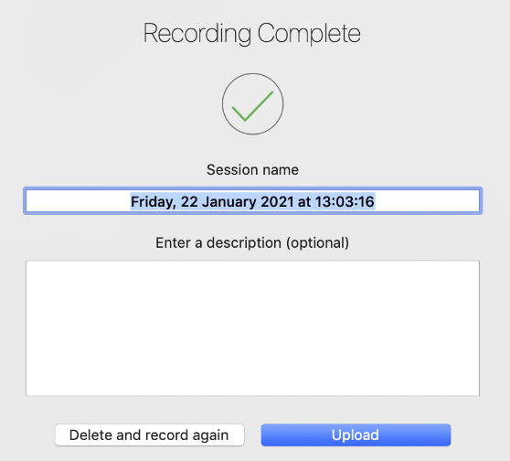

Creating a recording using the browser (Necessary for Chromebook)
Chromebooks cannot install the Panopto software so must use the Chrome browser recording option instead. This option can be used by anyone, but the installable Panopto software offers more features.
This video explains the entire process. https://howtovideos.hosted.panopto.com/Panopto/Pages/Viewer.aspx?id=f494ab4f-5172-48cc-b500-ac6801106515&start=71.770325

1 Using Google Chrome browser, navigate to http://revision.derby.ac.uk/ | 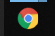
2 Choose Course Resources (default) and click Sign in.
3 Enter you university username and password.
4 Click on My Folder to enter your My Folder area. | 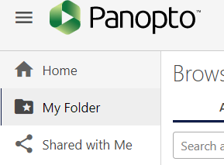
5 Click the blue Create button and choose Panopto Capture | 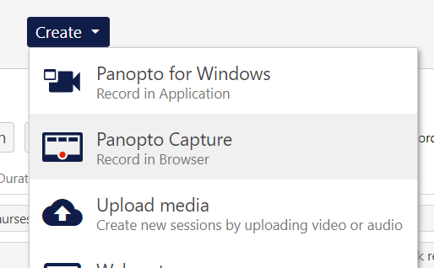
6 Select a mic.
Note: You may be prompted by your browser to give Panopto access to your microphone(s). If you accidentally block a device, please refer to our document How to Unblock a Device on a Browser for assistance.

If you want to use a different microphone from the one automatically chosen, select the microphone icon from the top toolbar (Fig. 3).
7 Each microphone connected to your computer will appear. Select the desired microphone, and a checkmark will appear over it.  Note: Test your microphone by speaking at a regular volume. The audio bar to the left of the microphone name should show green feedback as you speak.  If yellow or red feedback appears, the video's audio may be distorted. If no feedback appears, the microphone is not picking up audio. | 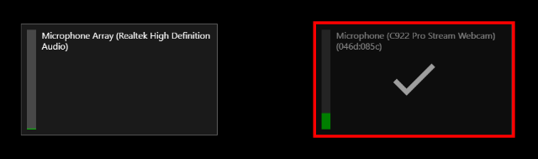
8 Note: You may be prompted by your browser to give Panopto access to your camera(s). If you accidentally block a device, please refer to our document How to Unblock a Device on a Browser for assistance.

If you want to use a different camera from the one automatically chosen, select the camera icon from the top toolbar.
9 Your connected cameras will appear and show a preview. Select the desired camera(s) and a checkmark will appear over the preview.  Note: The first camera selected, automatically or manually, will be used as the primary video source. Any additional cameras selected will be recorded as secondary video sources. To learn where these sources will appear in the viewer, please see Learn About the Features of the Video Viewer. | 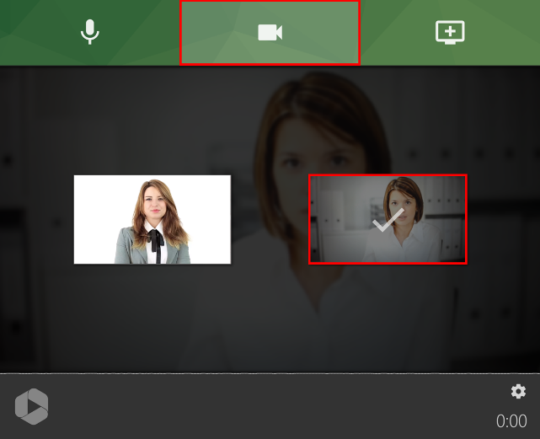
10 Select Screen and Application Sources

Mac users, please note: Depending on the browser you are using, you may need to give additional permission for Chrome or Firefox to access your screen prior to recording a PowerPoint presentation.

To learn more about this, please visit Why isn’t my screen being recorded on Mac when using Capture?
11 Chrome or Edge (Chromium-based) users: a pop-up window will appear that allows you to select between a screen, application, or browser tab:  To record everything that happens on a screen, choose Your Entire Screen. Then, click on the screen to record and click Share.  This is the recommended option. | 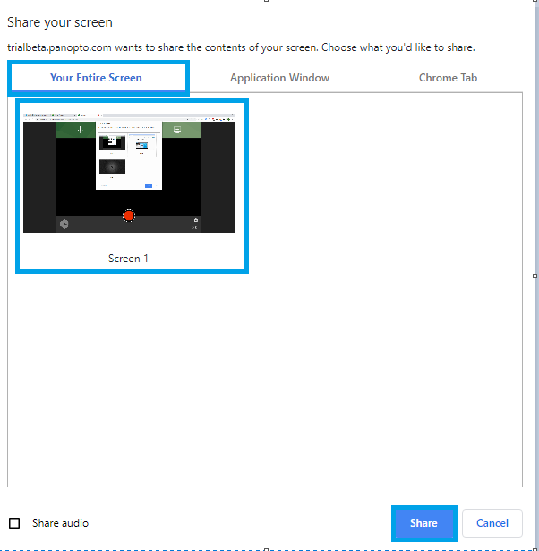
12 To begin recording your video, click the red circle button at the bottom center of Panopto Capture.
13 If enabled, you will see a 5 second countdown on screen, and then the recording will begin.

To learn about enabling a five second countdown, please visit Learn About Capture Settings.
14 To stop recording, select the red square button at the bottom center of Panopto Capture.

The video will immediately begin to upload. Do not close the Panopto Capture browser tab OR disconnect from WIFI until the upload is complete.
15 Once you stop the recording, a new page will load that shows the video’s progress. Do not close this page until you see the message Getting your video ready for editing: It's safe to close your browser window in the top left corner  Once the video has processed completely, it will state Your video is ready.  Panopto Capture uses failsafe recording. This means that even if your browser crashes or your computer turns off, your video will finish uploading next time you launch Capture. | 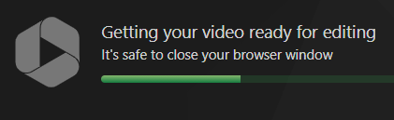
16 On the right side of the top toolbar you can select Redo and want to return to Panopto Capture to re-record, or select Record New to start again. | 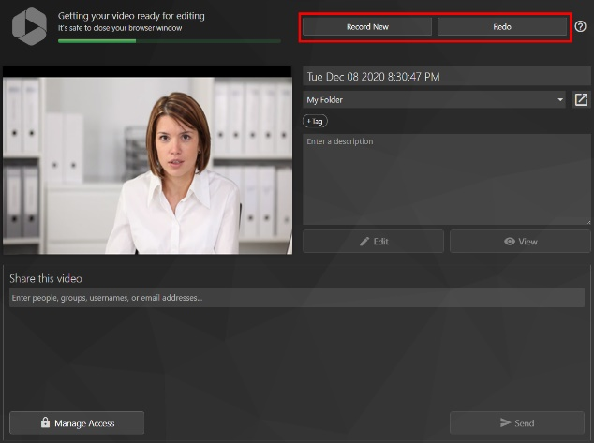
17 In the video details box you can:  edit the video’s name  change the video’s folder location (this should be My Folder)  enter the video’s description  open the video in the Panopto editor by selecting Edit  view it in the Panopto viewer by selecting View | 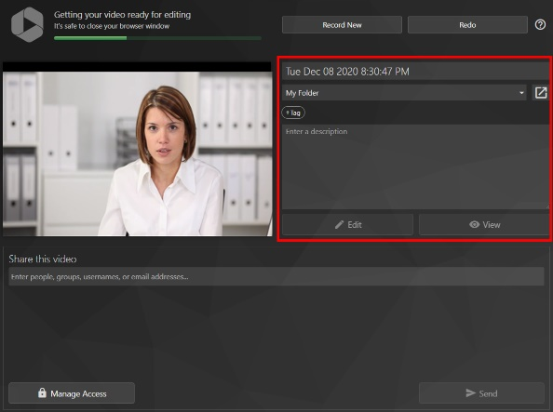
18 Now see the next section on Submitting your assignment.

Recording a video on a phone or tablet and uploading

1 Visit your app store, search for and download the Panopto app.
2 Open the app and enter you university email address.
3 Choose derby.cloud.panopto.eu if prompted with a choice
4 Choose Course Resources and choose Sign in
5 Enter you University username and password
6 In the app, select the circle plus + icon from the lower right corner | 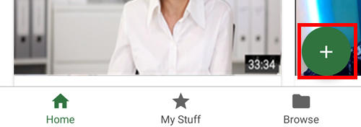
7 A pop up menu will appear at the bottom of your screen, select Upload and Record | 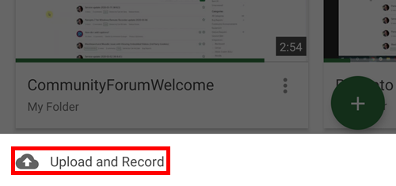
8 If you are asked to allow Panopto to take pictures and record video, and Audio, click Allow.
9 Ensure the folder is My Folder | 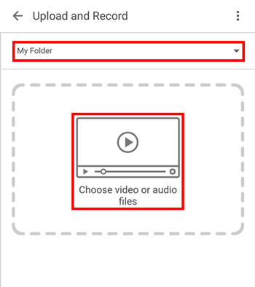
10 A pop up window, Choose an action, will appear.  If you want to record, select your Camera app icon. If you want to upload a video, select your Files app icon.  Note: this may appear differently, based on the device and operating system used. | 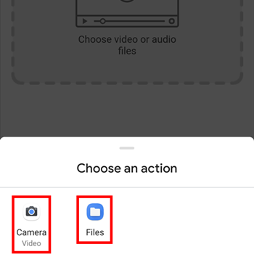
11 Once you are done recording or have selected the file you want to upload, your video upload will take place and process.  A green tick will appear next to the video once the upload is complete.  If you recorded a new video, you can name it by simply tapping on the device-provided name in this window and typing in the new name.  Note: It is important that you stay on this screen until your upload is complete. | 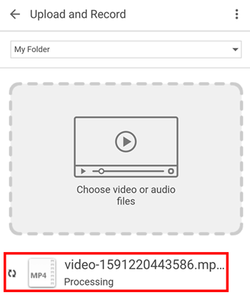
12 Your upload is now in the folder you selected in step 9. This should be My Folder.

Now see the next section on Submitting your assignment.

Submitting your assignment
This guide assumes you have already created your Panopto video and saved it to your My Folder area. See the guides above for this.
We recommend you use Google Chrome browser for submission as other browsers may not work correctly. You should make sure you allow popups in your browser as the process requires a pop up window to open to select your video for submission.

Finding your submission point and submitting
Your tutor will tell you the name and location of the assignment submission point, but they are usually in the Assessment area on Course Resources.
Note: Panopto video submissions do not use Turnitin so the process is probably different to what you do for written assignments. Please read the guide carefully. If you’re not sure contact your tutor.
1 Navigate to the module and find the submission point  The submission point has some instructions written into it. This guidance expands on those instructions. | 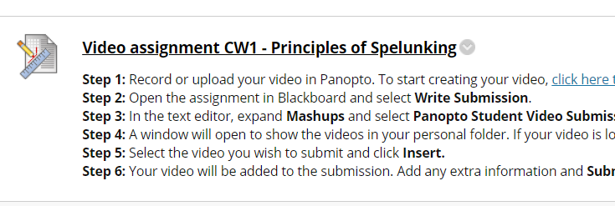
2 On the submission screen click Write Submission. | 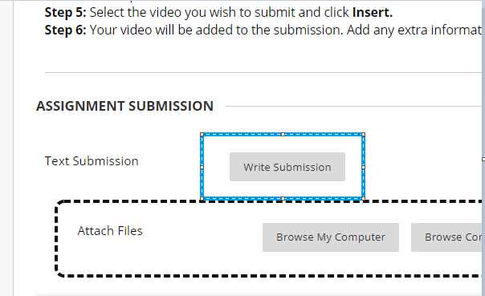
3 Ensure full toolbar is available in Instructions (click the chevrons to open) | 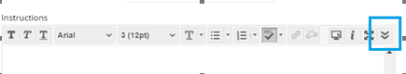  Chevron opens toolbar:  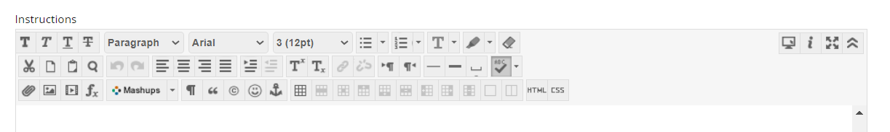
4 Click Mashups > Panopto Student Video Submission | 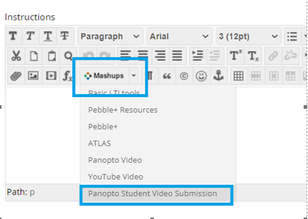
5 A pop up screen will appear linked to your My Folder area in Panopto.  Ensure that you allow popups in your browser if this screen doesn’t appear.  Contact IT Services helpdesk for support if stuck: 01332 591234. | 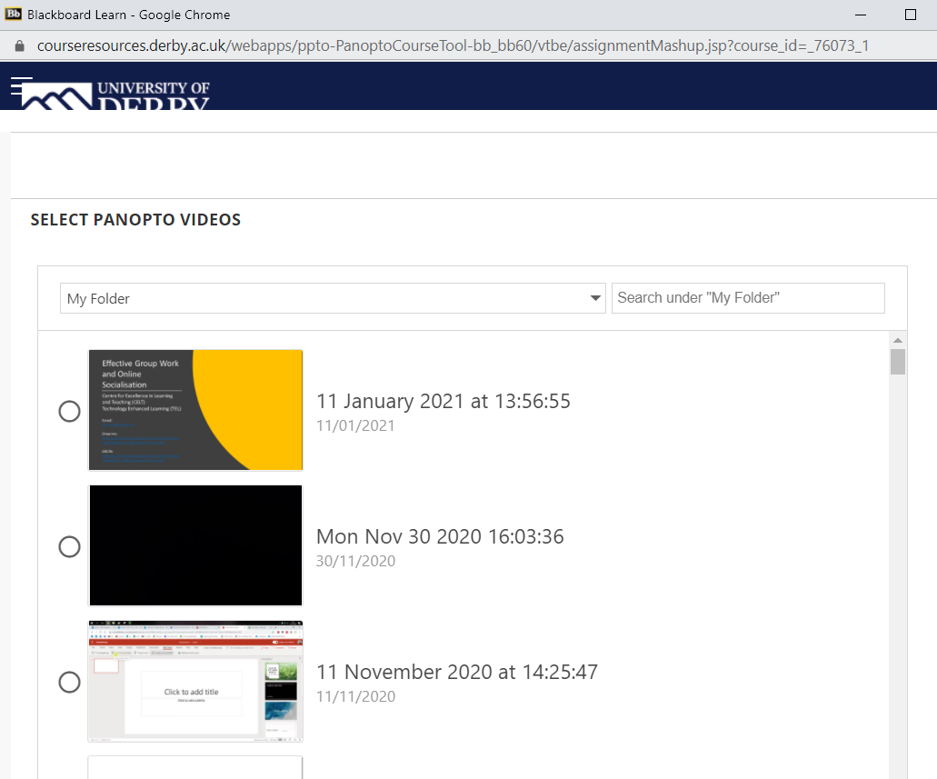
6 Click the video you want to submit. It will highlight. | 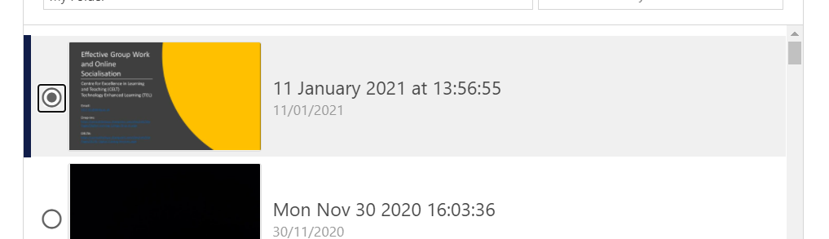
7 Scroll to the bottom of the window and click the Submit Video button | 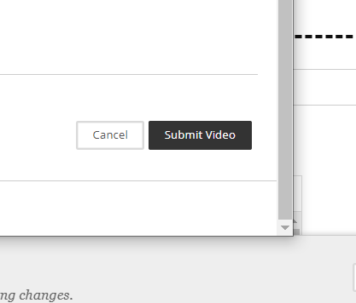
8 A link will appear in the submission box.  DO NOT EDIT OR CHANGE THIS LINK or your submission will not work.  You may add extra text under the link.  If the link disappears or changes, then cancel the submission and start again! | 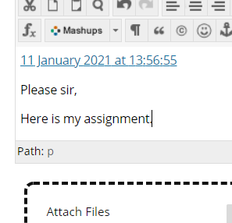
9 You can add documents to the submission as well, for example powerpoint, word or image files.  Click on Browse my Computer and find and select any additional files to submit. | 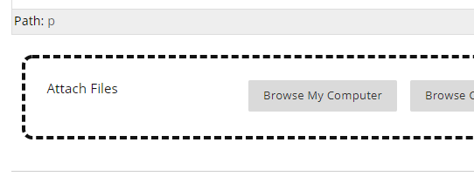
10 Click submit to submit the assignment. | 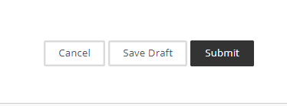

You will receive an email receipt for your assignment. Keep this as proof of submission. If you don’t get an email receipt, but you have submitted and there were no errors on the submission screen, contact IT Services and your tutor with an explanation and to get support.
IT Services: itservicecentre@derby.ac.uk
IT Helpdesk: 01332 591234

