What is Microsoft Forms?
Microsoft Forms is an online tool for collecting information. The responses are stored in the Forms area of Office 365, and you can see statistical information about the data, as well as download it in an Excel sheet.
You should watch the video and read the documentation below to gain a clear understanding of the process for creating and using quizzes.
Contents
Video walkthrough of using Quizzes in Forms 1
Log in to Microsoft Forms 2
Create a Quiz 3
Apply a Theme to your quiz 5
Add a text-based question 8
Add a multiple choice question 9
Assign points for each question 11
Assign which answer is correct 11
Preview the Quiz 12
Change Form Settings 12
Share your Form 14
Check and share your quiz results 15
Post scores 18
Analyze your quiz results in Excel 19
Credits 20

Video walkthrough of using Quizzes in Forms
Note: Recommended settings for sharing are: Only people in my organisation can respond; Record name.
This video demonstrates the entire process of creating a quiz.
https://www.youtube.com/watch?v=2C60NKWBV7M

Question Types

Question type | Explanation | Self-grading? | Useful for
Choice | A multiple-choice (one answer) or check-box (multiple answers) question with no correct answer Tip: Toggle on the Multiple answers option to make this a check-box style question | No | Multiple-choice and check-box questions that are not part of the quiz (e.g. selecting class or teacher)
Quiz | A multiple-choice (one answer) or check-box (multiple answers) question with a correct answer(s)Tip: Toggle on the Multiple answers option to make this a check-box style question | Yes | Multiple choice and check-box quiz questions
Text | A short or long answer text box  Tip: Toggle on the long answer option to give students a bigger box to type in. | No | Capturing student names, email addresses, feedback, explanations and text responses
Rating | A number or star rating out of five or ten | No | Capturing student feelings about a topic, performance, activity, teaching method etc.
Date | A date-picker box | No | Capturing date selections
File | Click on down arrow and File upload to add. Allows respondent to upload a file. | No | Uploading files from 10Mb to 1Gb in size such as word documents or pictures etc.

Log in to Microsoft Forms
To create any Forms you will first need to log in to the Microsoft Forms online portal.
- Open a web browser
- Click: https://forms.microsoft.com
- Click the Sign in link in the top right-hand corner
- Sign in with your Office 365 login username and password
- The Microsoft Forms homepage will be displayed

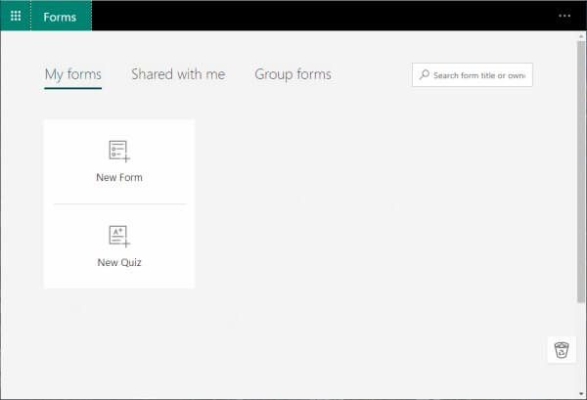
There are two types of forms you can create: a form or a quiz. There are a few differences between the two types:
- A form can be used to collect feedback, conduct surveys, accept signups, peer collaboration, and lots more.
- A quiz can be used to assess student learning, provide instant results and feedback, conduct a quiz and more.

Create a Quiz
Firstly we are going to create a basic quiz which will provide students with an instant result and score.
- Click New Quiz
- A new blank quiz will be displayed
- Let’s set up a few basics including the title, description and an image for our quiz
- Click the Untitled Quiz text to change the title
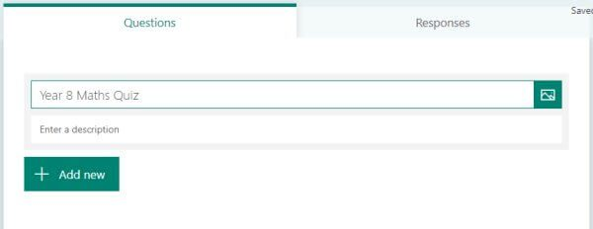
- Enter a description to give the end-user an idea of what the form is about or some instructions if needed
- Now let’s set an image to use for our quiz, this could be a logo, header image or just an image associated with the topic of your quiz
- Click the Insert Image button
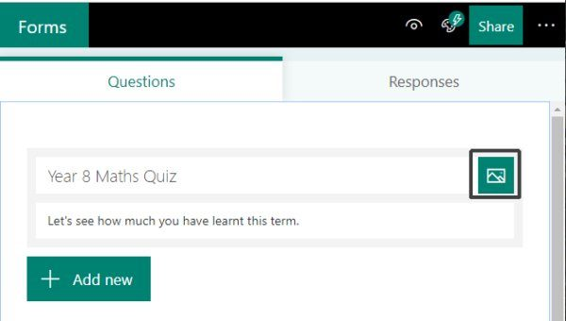
- You have the option of searching for an image using Bing, accessing images you have stored in your OneDrive account, or uploading an image from your computer.
- I am going to upload a free stock image I found via pexels.com so I will select the Upload option:
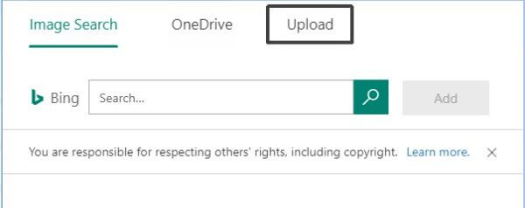
- Locate the image you wish to use, select it and click Open
- The image will be added to your quiz header area
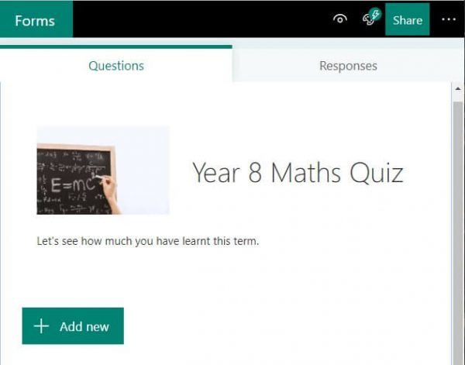

Apply a Theme to your quiz
One way to jazz up the look of your quiz form is to apply a theme. The theme allows you to customise the background area of your form either with a solid colour or with a background image. Microsoft Forms will allow you to use their built-in Theme Ideas or upload your own image.
- Click the Theme button
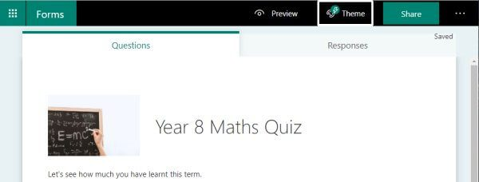
- The Theme Ideas pane will appear. The magic in this section is that the theme ideas will customise depending on the title of your quiz. Experiment if you like by changing the topic of your quiz to something completely different, then see the different theme ideas it provides you.
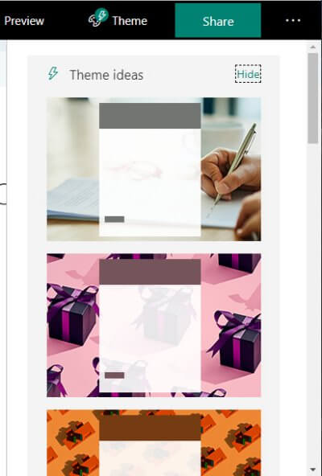
- Choose a Theme you like for your quiz
- If you would like to use a solid colour or even upload your own image to use as the background, click the Hide link in the top right corner of the Theme Ideas pane
- There will be options for solid colours along with some additional themes. You will also have the option to click the + button and upload your own image.
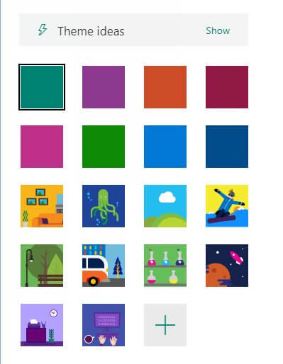
- You should now see the theme applied to your quiz
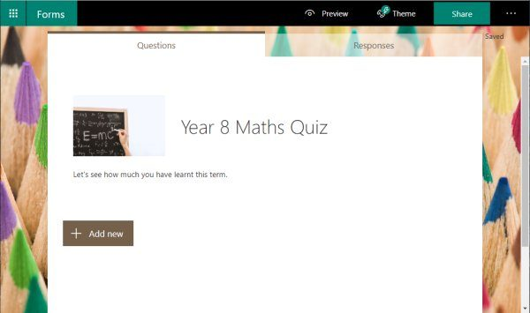

Add a text-based question
Now to add questions to our quiz. Firstly we are going to create questions to collect the name and email address of who is filling in our quiz.
If you are using the quiz for students who are part of your main school Office 365 organisation unit, then the students’ details will automatically be displayed on their responses. If however, you are planning to quiz a mixture of people within your school organisation unit and external users, it is recommended to add fields to collect their name and/or email address. If you do not then each response will be labelled Responder 1, Responder 2 etc with no names associated.
- Click the Add New button to add the first text-based question
- From the options select Text
- A blank text question will appear
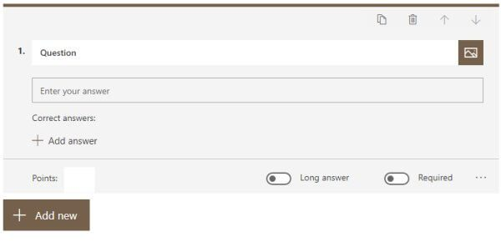
- Type the first question into the Question field e.g. Your Name
- Repeat this and add a text question for Your Email
- You may like to make both of these fields required, meaning that your students MUST enter their details
- Click on a text question to open the editing options, click the Required button to enable it
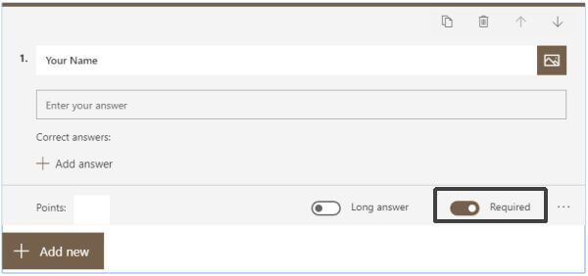
- Click outside the question area to close the editing screen
A Text-based question allows you to assign an image to the question or add a list of correct answers. You can set the question to allow a long answer, or make the question a required field as we have done above. For more options, click the ellipses (…) button in the bottom right corner and enable additional settings such as Subtitle (add additional instructions or a prompt for the question), Restrictions (specify restrictions such as only allow a number between certain values), and Maths (allows you to enter a Maths equation).

Add a multiple choice question
We are going to use the Choice question type which will allow students to select from multiple-choice questions. We are also going to incorporate some images into some of our questions to work as a visual element to our question. Because we would like our quiz to automatically let students know their results, we are also going to assign points to each question and specify which question is the correct one so that the form can automatically let the student know their result.
- Click the Add New button
- Select the Choice question type
- A blank Choice question is displayed
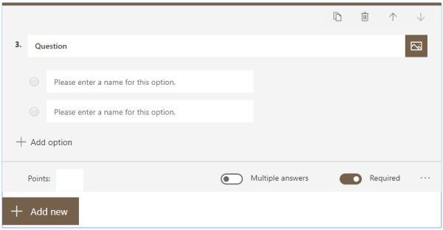
- Type the next question into the Question field
- My first choice question has a visual prompt, so I need to add the image into the question. To do this click the Insert media button
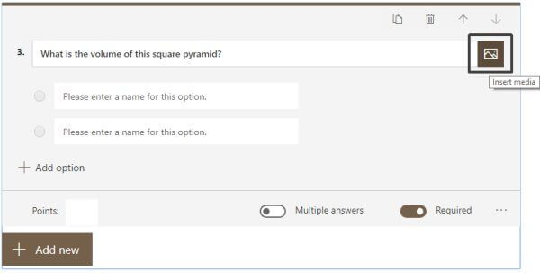
- From the Insert media pane select Image
- Now select the source of your image, you can use a Bing search, select an image from your OneDrive, or Upload.
- I am going to choose Upload as I have the image saved on my computer
- Select the image and click Open
- The image will now be added to the question
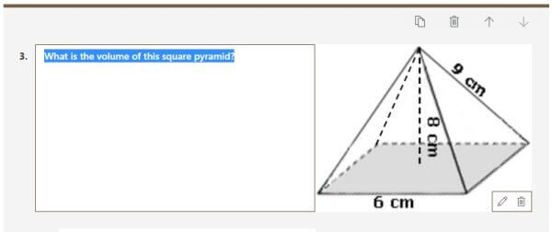
- Now add the answers into the fields provided
- To add more answer options, simply press Enter at the end of the last answer or click the + Add Option button

Assign points for each question
So that your quiz can be automatically marked, you need to indicate how many points each question is worth.
- From the question area, click into the Points field and enter the value for this particular question
- I am going to allocate 5 points to each of the questions in my quiz
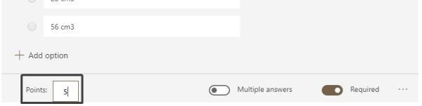

Assign which answer is correct
Our final step is to indicate which answer is the correct one so that the automatic marking process can function.
- From the question area, hover over the correct answer from the list
- Individual options for that particular answer will be displayed
- Here you can delete an answer, enter a message to be displayed if a respondent chooses that particular answer, or mark it as the correct answer
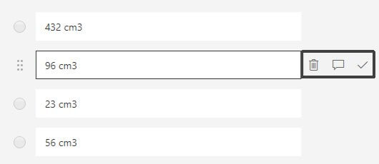
- Click the tick icon for the correct answer for your question
- It will now display “Correct answer” next to the answer (this is not visible when respondents are completing the quiz)
- Repeat this process to create any additional multiple-choice based questions in your quiz

Preview the Quiz
To preview the quiz and check what it will look like, click the Preview button on the main menu area.

Change Form Settings
There are various different settings you can customise which affect who can view your form, when it can be viewed and also what type of notification you will receive. You can also enable or disable the ability to display results for a quiz automatically.
- Make sure your Form is visible
- Click the ellipse (…) button from the main menu area
- Choose Settings
- You can now enable or disable the Show results automatically setting. This displays the answers immediately after the student has submitted their quiz.
- If you switch off Show results immediately then students will not see their results until you Post Answers (see below).
- By default, your form will be set to only allow people within the organisation (i.e. University of Derby) to respond to the quiz. This is the recommended option.
- If you want to capture the name of the student, tick the Record name. This will add the name of the student to the results.
- If you only want students to have one try, tick One response per person. For multiple attempts, leave this unticked.
- To open it up to anyone who has the link, select Anyone with the link can respond. This is not recommended.
- Next, you can specify some additional options including the ability to set a start and end date for when your form will be open for responses, shuffle questions and also customise the Thank you message. Tick the options which apply if needed.
- You cannot specify the length of the quiz duration, only the dates and times when it is available. This could be used for a set time exam if these options are set, but students will only be able to access this during that time period.
- Finally, you can specify some notification settings. If you would like students to receive an email when they have completed the form, select the Send email receipt to respondents. If you wish to receive a notification when someone fills out the form, select the Get email notification of each response.

Share your Form
Now it’s time to share your form so that you can begin receiving responses.
- With the form visible, click the Share button
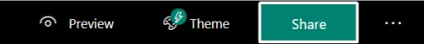
- You can again choose between having only people within your organisation/school to access the form or anyone with the link.
- We recommend you use Only people within your organisation.
- There is an option to directly copy the Form link. Click the Copy button to grab the link. You can paste this into a Course Resources announcement, into a section on the module like study materials or assessment or send via email.
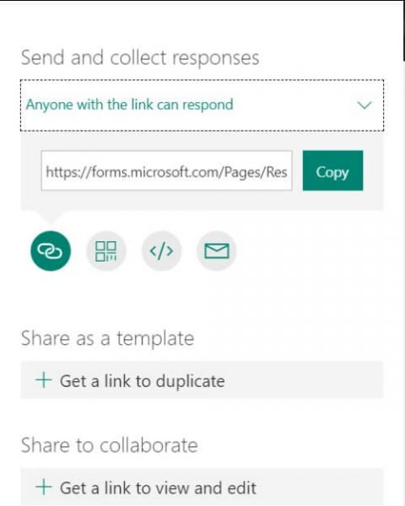
- Alternatively, you have 4 buttons which provide options for sharing your form: Link, QR code, Embed, or Email.

Check and share your quiz results

Microsoft Forms provides a rich grading workflow that enables you, as the author, to efficiently award points per question to students and provide feedback in a number of ways. You can export quiz results to Microsoft Excel for more in-depth analysis and charting, as well as delete or print a summary of all responses.
View response summary information for your quiz
In Microsoft Forms, open the quiz for which you want to review the results, and then click the Responses tab.
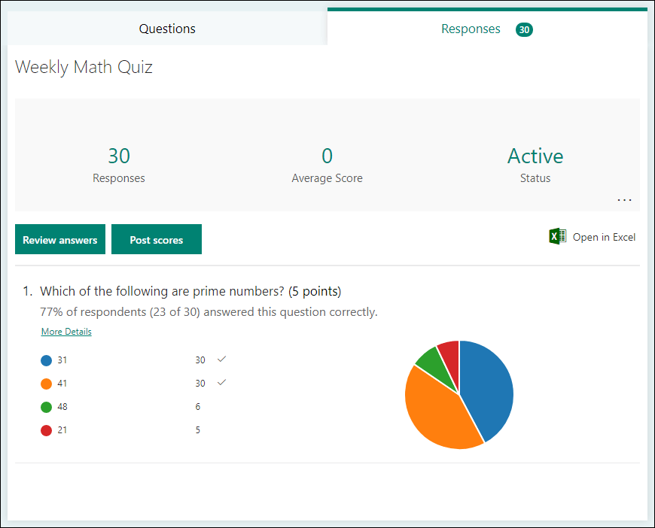
Across the top, you’ll see real-time summary information about your quiz, such as number of responses and average score. Next to each question, you’ll see the number of responses and a chart that shows the ﻿distribution of responses across all of the possible answers.
You can click More options to delete all responses, print a summary, or get a summary link to share with others.
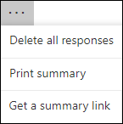
Review answers for each question
Click Review Answers to provide points and feedback.
On the People tab, you can see individual details for each student, such as time it took to complete your quiz, number of points earned, and the option(s) your student selected.
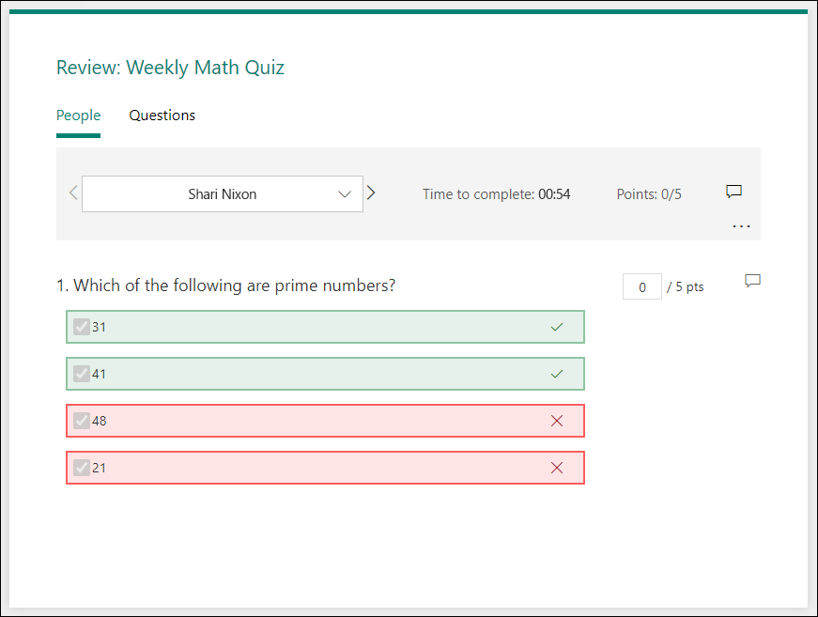
In this view, you can grade all questions for one student, then do the same for subsequent students. Click the arrow next to a student's name to jump to the results of another student. You can also click the left and right arrows to toggle through the result details of the other students.
To provide general feedback for a student, click the feedback icon and type in the text box.
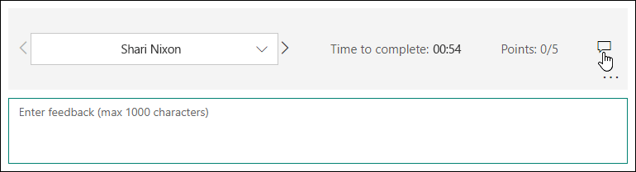
To provide feedback for a particular question, click the feedback icon to the right of points, and then type in the text box.
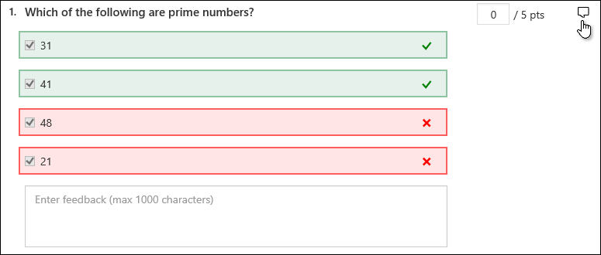
You can also click More options and choose whether to Delete response, Print response, or Post scores for a particular individual.
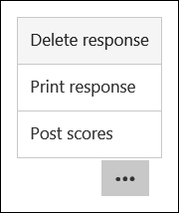
Note: Deleting a response cannot be undone.

Post scores

If you have set “Show results immediately” to off in the settings, then you must post scores so students can see the results.
When you're ready to share your feedback and points to students, click Post scores in the Responses tab.
For each student, you can see the status of their quiz and number of points earned. If you want to post the scores of all students, click the check box to the left of Name in the Name column. To post individual scores, click the checkbox to the left of each student's name.
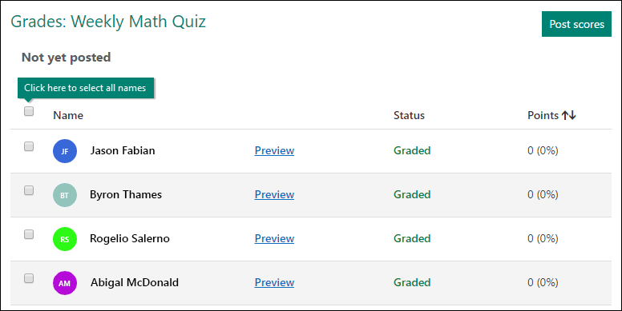
Click Post scores.
Once you post scores, you can go back to your quiz to review your results and feedback. Students ﻿can view their scores and feedback by opening the quiz.
Tip: If a student goes back into a quiz after submitting, they'll be able to see their previous responses. If you want them to retake the quiz without seeing their responses, you can create a copy of the original quiz.

Analyze your quiz results in Excel
You can easily view all of the response data for your quiz in Microsoft Excel. Click Open in Excel on the Responses tab.
In your Excel workbook, details of each question in your quiz are represented in columns and each response is shown in a row. The first five columns display respondent ID, start and completion times for each response, and the name and email address of each student. The subsequent columns display total points, quiz feedback, grade posted time, quiz questions, points for individual questions, and feedback for individual questions.
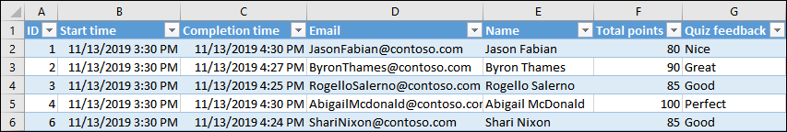
Notes:
- The respondent ID is exclusive for each student.
- Any changes you make to the quiz data in Excel won’t modify the content of your quiz.
- Names and email addresses won’t be displayed if you allow your quiz to accept anonymous responses.

Credits
Video: Prolific Oaktree (https://www.youtube.com/channel/UCgvZvNWjPkX8ESEJJHRF1rg)
Documentation:
The Training Lady (https://www.thetraininglady.com/create-online-quiz)
Microsoft (https://support.microsoft.com/en-us/office/check-and-share-your-quiz-results-c4a9b45c-d62f-4eb7-b5db-ad81892c7c07)

