Padlet Training Guide
Part 1 How to login to the University Padlet account
Part 2 Create a new padlet
Part 3 Embed the padlet in Course Resources
Part 4 Writing notes on a padlet

Part 1 Logging in with the University account

1 Log in to Padlet using the University’s account.  NOTE: You must use this link rather than the normal Padlet site. | https://derbyuni.padlet.org
2 Click Log in with Microsoft
3 Enter your university username, click Next | 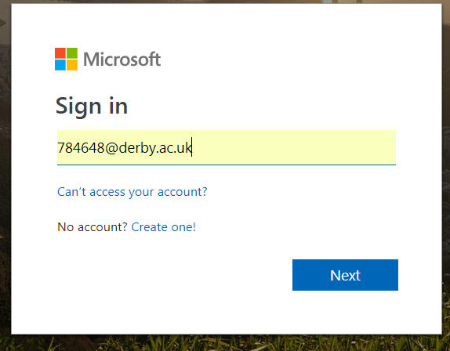
4 Click Work or school account. | 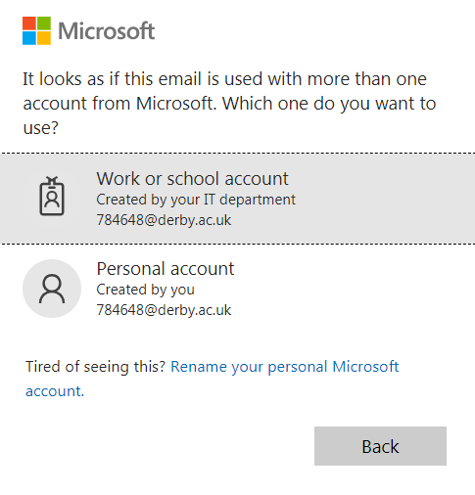
5 Enter your password, click sign in. | 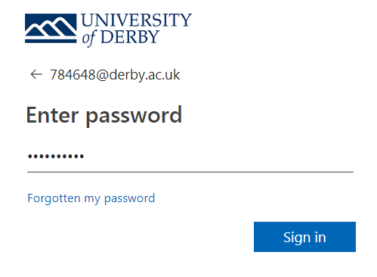
6 You’re signed in to the Padlet dashboard. | 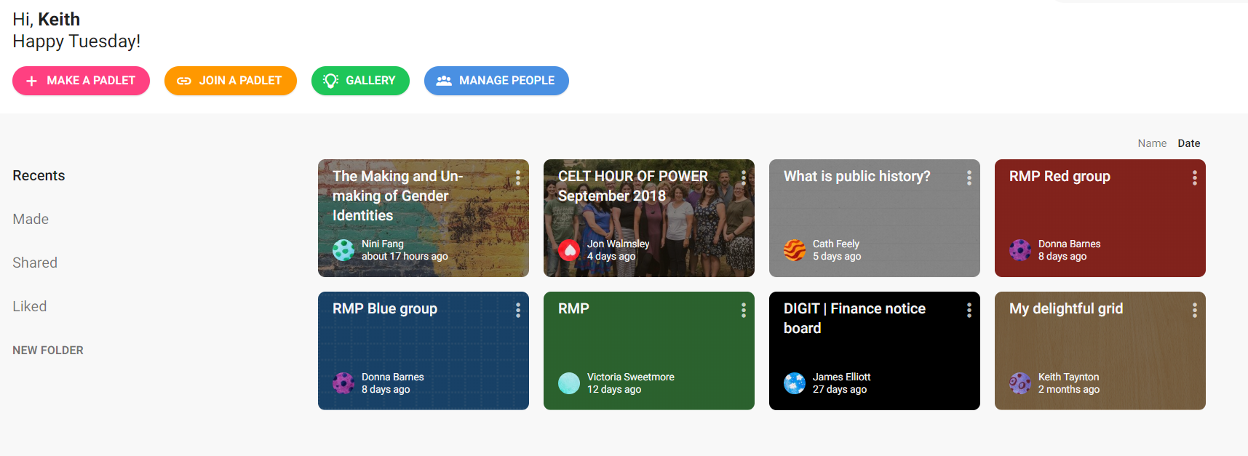

Part 2 Create a new padlet
This guide sets up a padlet that
- Creates a padlet that is available to anyone with the link
- Students can write notes on without logging into Padlet (anonymous)
- Posts are unmoderated and available immediately
- Allows comments on notes by anyone with the link (anonymous)
- Embeds the padlet into Course Resources

1 Click on Make a Padlet | 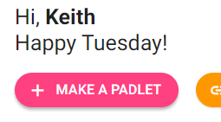
2 Choose your wall format by clicking Select.  There are various options for how the notes are displayed on the wall. | 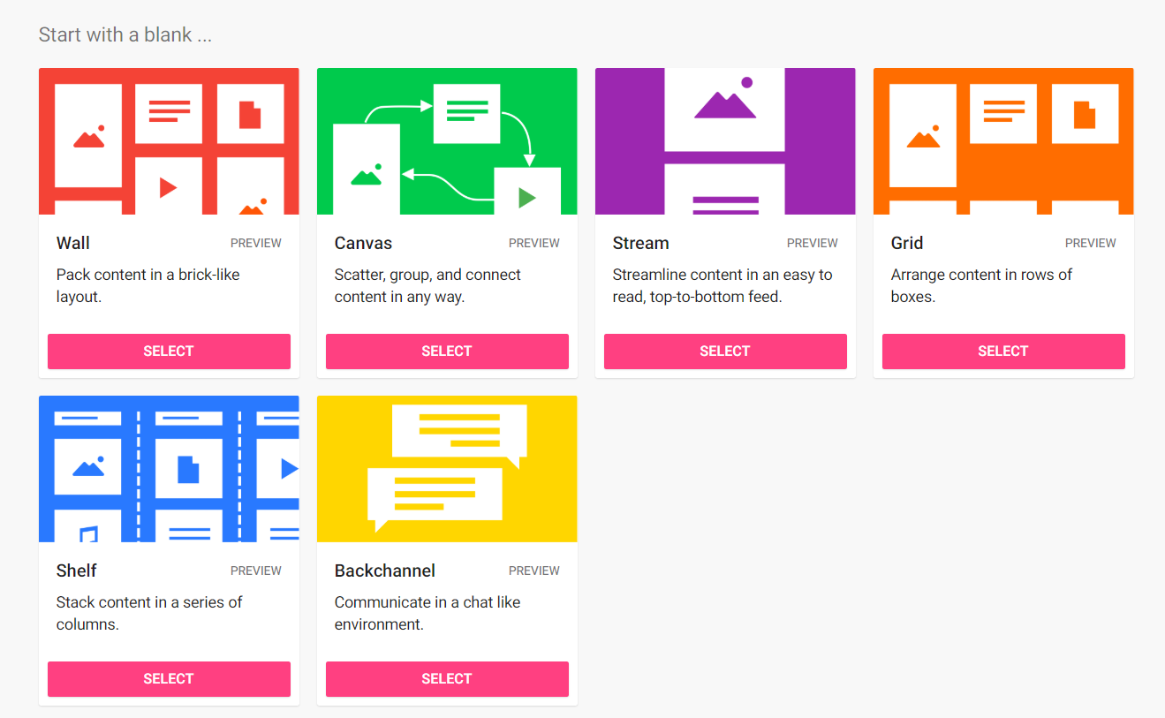
3 Alter the Title and Description.  Change the Icon, address and wallpaper, colour scheme and font as desired.  Leave Attribution and Comments to off (default setting). | 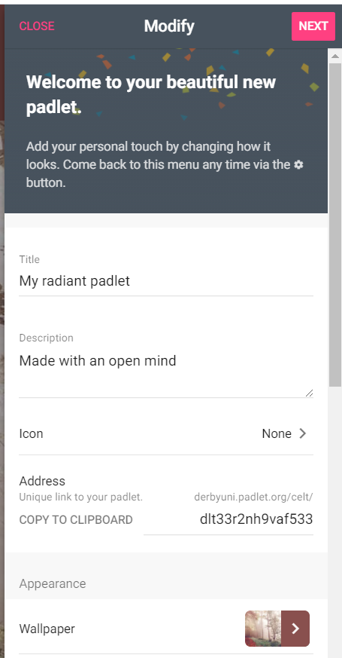  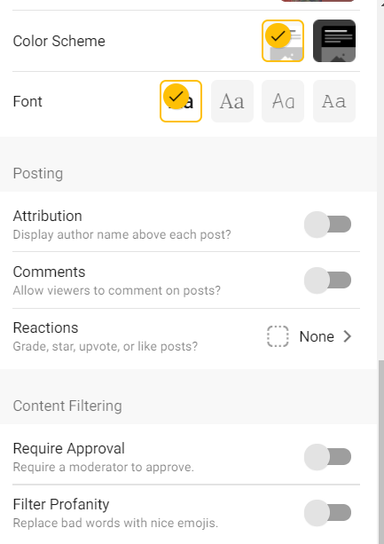
6 Click Next on the top right. The Padlet is ready to use.
7 Click Share in the top right.
8 Click Change Privacy | 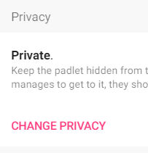
9 Click Secret | 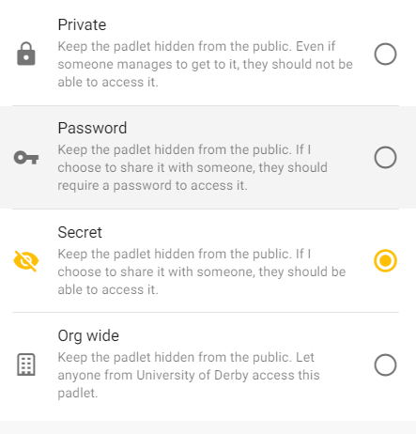
10 Click Can Read
11 Click Can Write, then click below the white box to disappear then box | 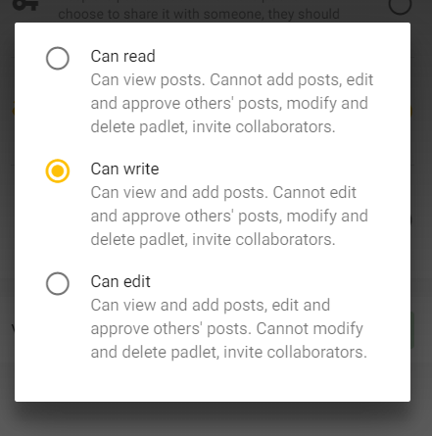
12 Click Save in top right

3 Embed Padlet into Course Resources
Get the embed code from Padlet
1 Click Share in top right
2 Click Embed in your blog or website. | 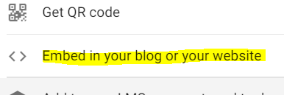
3 Click Copy | 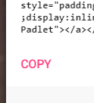
4 Navigate to your module | https://courseresources.derby.ac.uk/
5 In Study Materials click Build Content > Item | 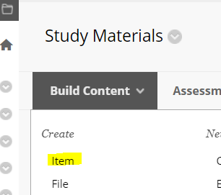
6 Enter a name (e.g. Discussion of Spelunking) | 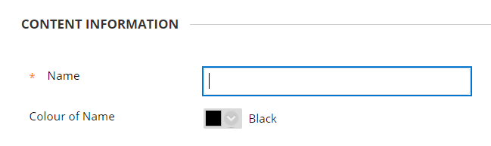
7 (Optional) Ensure the full toolbar in the writing area is expanded by clicking the down arrows. | 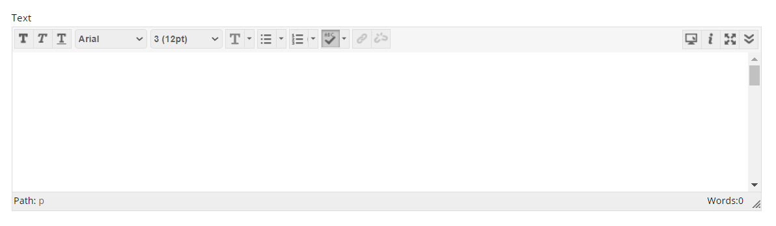  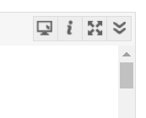
8 Click HTML | 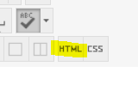
9 In the pop up window, paste the embed code from step 3 | 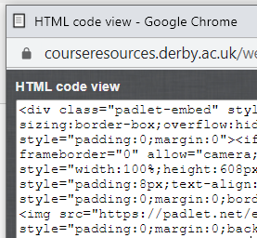
10 Click update on the pop up HTML window | 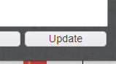
11 A yellow box is in the writing window.  Click Submit to save the Item. | 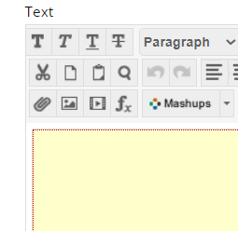  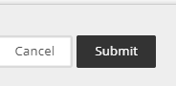
12 The padlet is embedded in the Course Resources page and students can start posting. | 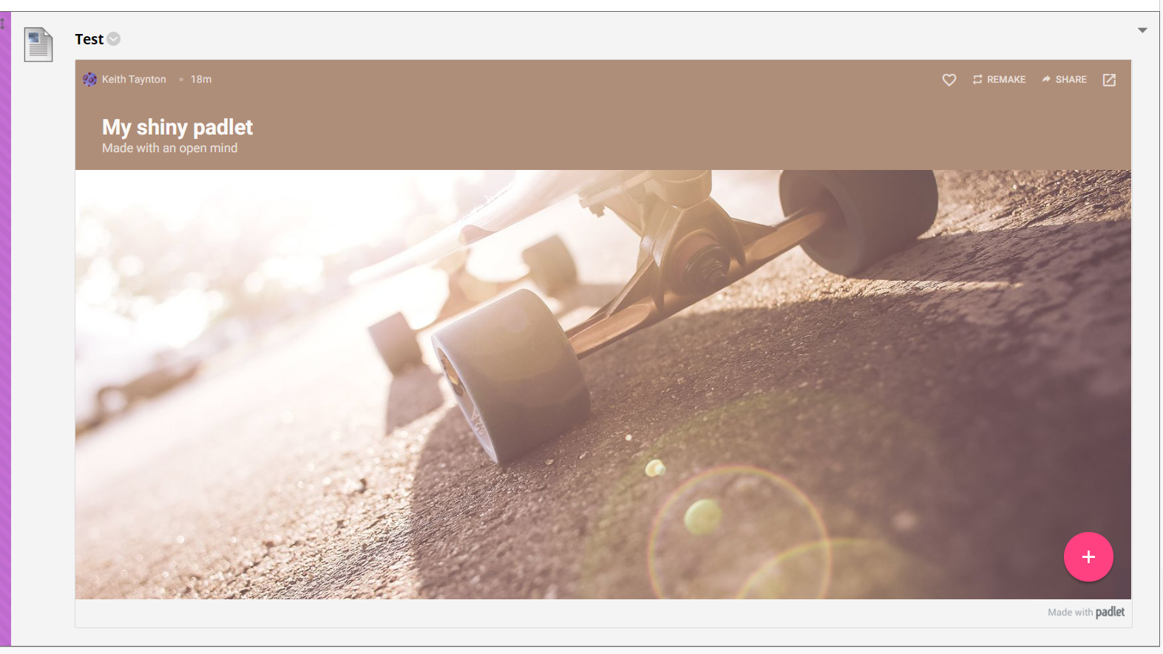

4 Using Padlet
You can send this to students as guidance.
1 To create a new Padlet note, double click on a blank space on the screen, or the Plus icon on the bottom right.  A note will appear.  Enter a title and some content. | 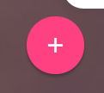  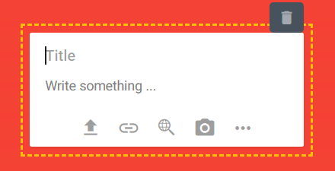
2 There are extra options in the bottom toolbar.  Up arrow is upload a file.  Broken circle is add a link.  Magnifying glass is google search to embed images, video, gifs and web  Camera takes a photo from a connected webcam  Click the three dots to get more options. | 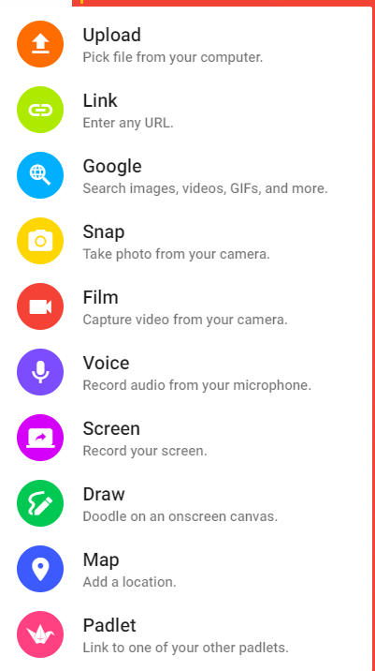
3 The rubbish bin deletes the note.

