Panopto Video Assignment Submission using Course Resources Assignment

If you want to create a video assignment submission point you can use the Course Resources assignment feature. This functionality integrates Panopto recordings and Course Resources Assignments.
Benefits are:
- Students get an email receipt of submission
- You can set open and close dates/times on the Assignment / set up late submissions
- Anonymous marking supported
- Grades go into Grade Centre
- Feedback goes in the Assignment area so students can access it via Grades and Feedback
- Grade goes into Grade Centre
- Tutor and External Examiner access without having to manage files
- Simple to view the submission
- Simple for students to create and submit a video
- Students can upload supporting documentation alongside the video (e.g. Word or Powerpoint)
- You can use Course Resources (Blackboard) Rubrics (not compatible with Turnitin)

Ensure you download and send students their step by step guide found here.
Contents
1 Creating the Panopto Assignment 1
2 Student submissions 3
3 Viewing and Grading 3

1 Creating the Panopto Assignment
1 Navigate to the module and select Assessment. | 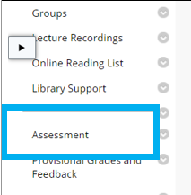
2 Hover over Assessments, then click Assignment | 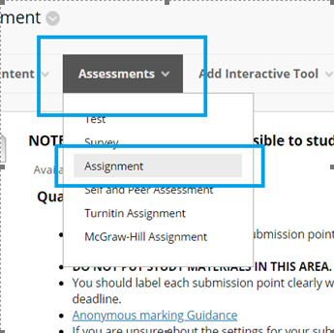
- Enter assignment name | 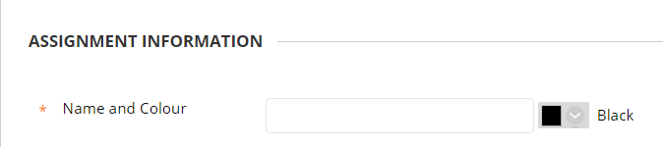
3 Ensure full toolbar is available in Instructions (click the chevrons to open) | 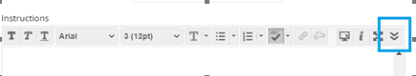  Chevron opens toolbar:  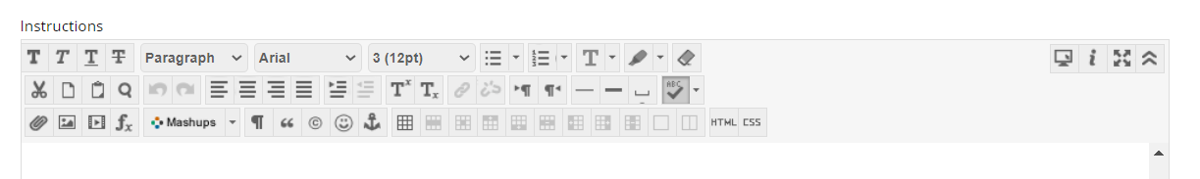
4 Click Mashups > Panopto Student Video Submission | 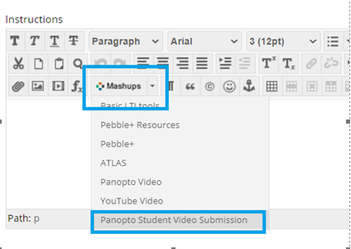
5 The Instructions box will automatically complete with instructions for students on how to submit their video.  Add any other information to the description. | 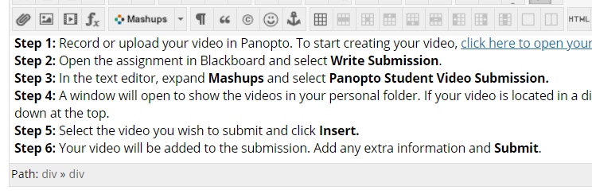
6 Complete the set up of the Assignment, including dates, anonymous marking and points for the assignment. | Read the set up guide for a Course Resources Assignment.
7 Check your settings and click Submit | 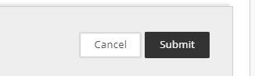

The assignment will now be available for students to submit to.
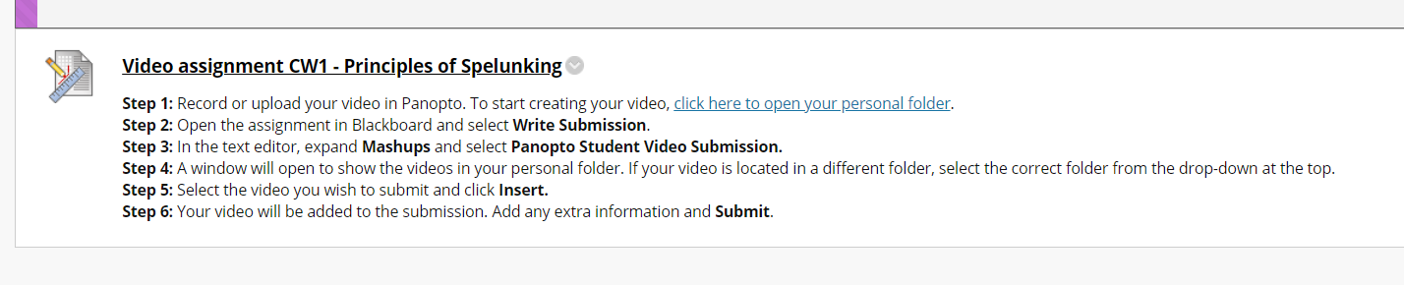

2 Student submissions
A separate student guide is available in the Digital Practice Handbook which you should send to students / add to your Assessment area so they can complete submissions successfully.
Please check the Panopto Video Assignments page on the Student help guide. You can direct students here so they can access the material.
https://courseresources.derby.ac.uk/webapps/blackboard/content/listContentEditable.jsp?content_id=_4483780_1&course_id=_12174_1&mode=reset

3 Viewing and Grading
1 Navigate to the module

2 Click Grade Centre > Full Grade Centre | 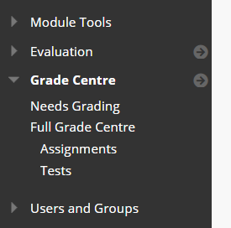
3 Click on the down arrow on the assignment column. | 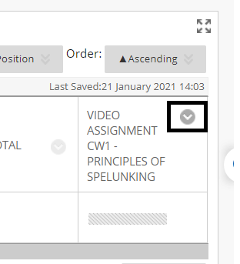
4 a  Click on the Grade Attempts menu item.  The first submission attempt will display. | 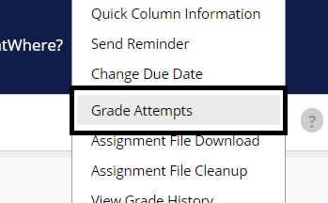
4 b  You can navigate to different attempts using the arrows on the Attempt ID | 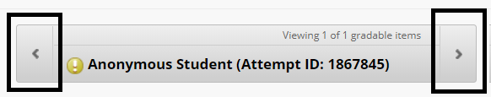
5 Click the link in the submission to open and view the video.  Additional documents may also be submitted which you can access on the screen as well. | 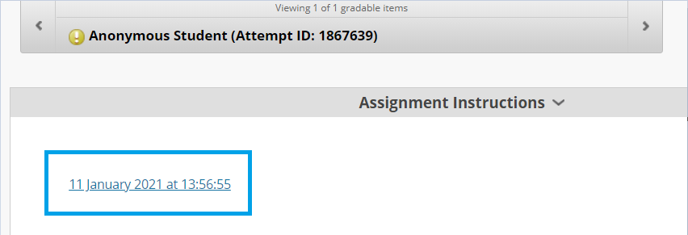
5 Add feedback and a grade on the right.  Click the down arrow to get the feedback box.  In the feedback box you can also attach a file (e.g. feedback template etc). Click the paperclip to add a document. | 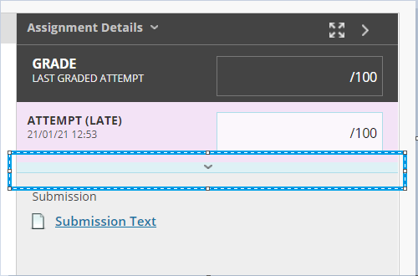  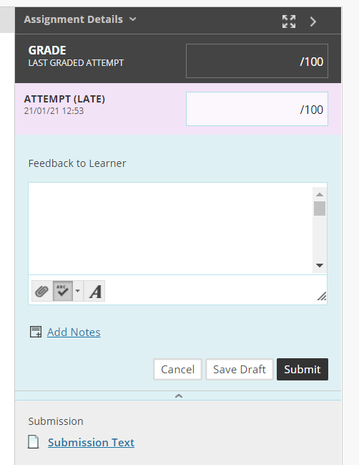
6 Click Submit to save your grade and feedback.

